Community Brokerage Model Self-Assessment Tool

This self-assessment tool is for use by any organisation that wishes to develop its approach to align with the community brokerage model as described in the National Brokerage Framework. It helps the organisation measure its progress towards the model by asking specific questions that relate to the community brokerage model and brokerage practice. The tool enables the self-assessor to check the question against what the framework says about that particular topic and to give their response as they see it within their own organisation. Through a useful key and on completion of the questions they can allocate a score to each question. Placing their total score within the scoring table provided they can identify their progress and if they measure red, amber or green towards their goal of being an organisation that uses the community brokerage approach.

This self-assessment tool is not a performance management tool or an evaluation tool to measure impact. The purpose of the tool is to measure progress towards the community brokerage model and to help identify areas where further work is needed in the organisation’s journey.

About Community Brokerage

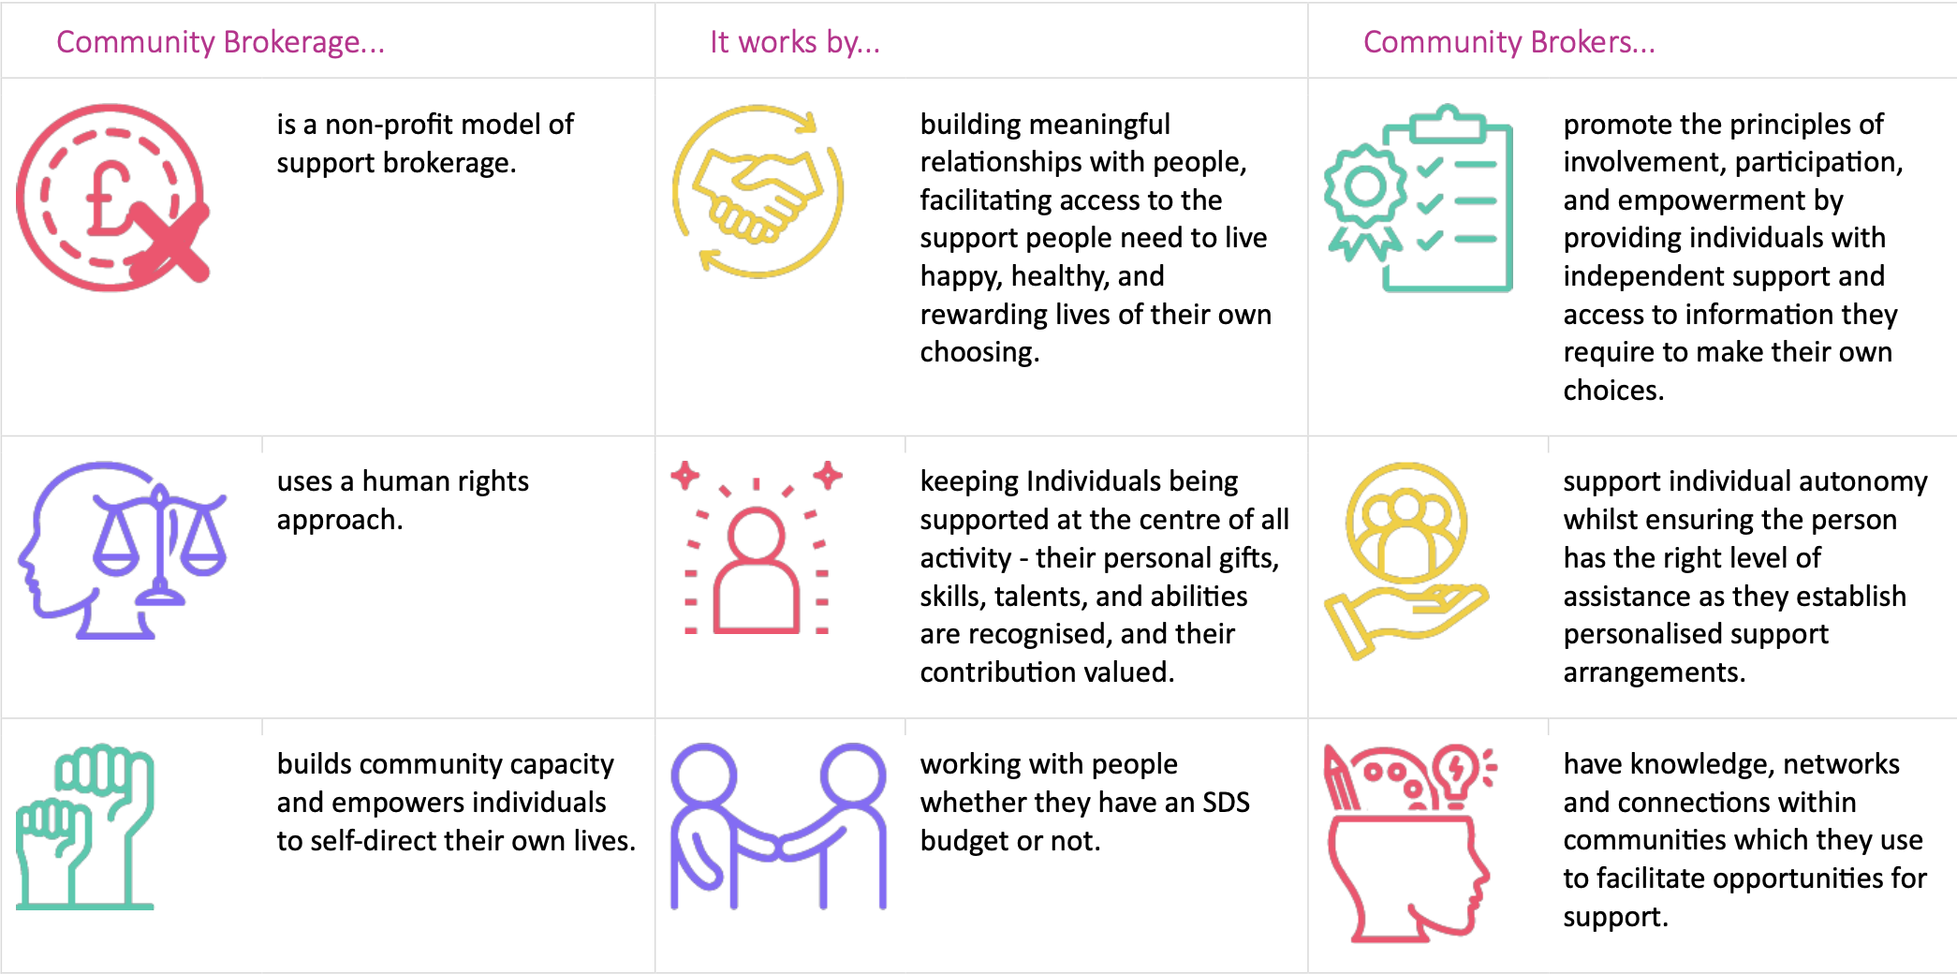

Community Brokerage Model Self-Assessment Template

Explanation and Guidance for Completing
- The left-hand column contains the questions (criteria) against which you are being asked to provide a response, and they are based on what constitutes the community brokerage model.
- The second column gives the page(s) in the National Brokerage Framework where additional information relating to the question/model can be found within the document.
- The third column headed ‘examples/explanations’ is where you provide your response to the question. This should be considered as providing your evidence to help you decide your score.
- The last column is where you score yourself out of a maximum of 5 points based on the evidence you provided in the ‘examples/explanations’ column.
- Questions 12, 13 and 14 requires each bullet point to be scored out of 5
- Question 16 has its own explanation detailed.
- There is a key on page 4 that will help you decide what score to give your evidence/response.
- There is a table on pages 10 and 11 that will help understand what your score means once you have added it up and finally colour code it either red, amber or green.

Key to use for allocating your scores
Based on the evidence you have provided in your response to each question, you should use this key to determine the score you want to allocate to the response. Remember to check the relevant pages in the National Brokerage Framework document as indicated in the second column. Doing this will help you judge which score to pitch for your response.

Description | Score
Do not meet this criterion | 0
Partially meet the basics of this criterion and provided limited evidence | 1
Meet less than half the criterion and provided fair evidence | 2
Meet half of this criterion and have provided good evidence | 3
Meet most of this criterion and have provided very good evidence | 4
Fully meet this criterion and have provided strong evidence | 5

Community Brokerage Model Self-Assessment Template

Name of organisation
Are you a ‘not for profit ‘organisation?
Number of paid employees in organisation?
Date of Self-Assessment
Date(s) of any previous self-assessment

Criteria | Brokerage Framework reference | Explanation/Examples | Score
- Explain how you are working towards the community brokerage model as expressed in the Community Brokerage Framework? | P 8, 9
- How many staff are working in a brokerage way? | P 12,13
- How many employees have completed the SQA Community Broker Award? | P 33
- How many staff are members of the Approved Brokers Community of Practice? | P 34
- How are you using a human rights-based approach to your work? | P 8
- Explain how you are independent from the local authority? | P 17
- If you are not fully independent from the local authority, explain how you retain your autonomy? | P 17
- How do you build capacity in the community through your work? | P 9, 22
- What is the approach taken by your staff to build collaborative relationships with others? | P 14
- How does a person-centred approach to practise operate within your organisation? | P 8
- Give examples of how your staff have supported people to use their gifts skills and abilities. | P 8, 19
Subtotal

- In what ways do you support people who: | P 11 | Score each bullet point individually out of 5
- Have no SDS funding/resource in place
- Receive Option 1
- Receive option 2, 3 and/or 4
- Receive ILF
- Receive Access to Work monies
- Self- fund their support
Subtotal

- In what ways do you support people who: | P 11 | Score each bullet point individually out of 5
- Have no SDS funding/resource in place
- Receive Option 1
- Receive option 2, 3 and/or 4
- Receive ILF
- Receive Access to Work monies
- Self- fund their support
Subtotal

- In what ways do you support people who: | P 11 | Score each bullet point individually out of 5
- Have no SDS funding/resource in place
- Receive Option 1
- Receive option 2, 3 and/or 4
- Receive ILF
- Receive Access to Work monies
- Self- fund their support
Subtotal

- In what ways does your staff promote the principles of SDS? These are: | P 18 | Score each bullet point individually out of 5
- Collaboration
- Dignity
- Informed choice
- Involvement
- Participation
Subtotal

- Explain how the following core values are evident in your organisation? | P 20 | Score each bullet point individually out of 5
- Respect
- Integrity
- Equality
- Citizenship
- Quality
Subtotal

- Describe how well connected into the community your staff are. | P 12
Subtotal

- What tasks do your staff undertake? | Input 1 if yes |  | Input 1 if yes
A |  | B
Build relationships with people |  | Secure support as agreed
Assist people who don’t meet eligibility criteria |  | Source solutions to challenges
Support carers |  | Mediate for the individual
Maximise independence |  | Advocate – pass to advocacy services if complex
Provide a range of information |  | Help people to make choices
Contribute to/manage risks |  | Provide technical assistance
Explain the SDS options |  | Support to challenge the HSCP decisions
Signpost to other resources |  | Carry caseloads
Provide advice |  | Maximise use of technological support
Maximise opportunities for natural support |  | Negotiate support costs with providers for individuals
Maximise informal support options |  | Keeps records
Help people prepare for needs assessment |  | Use skills of inquiry
Support people after assessment |  | Provide emotional support
Develop support plans |  | Provide payroll services
Cost support plans |  | Assistance with banking requirements
Build community capacity |  | Assistance with recruitment
Assist with implementing support plans |  | Assistance with insurance
Promote personal agency
Subtotal |  | Subtotal
Subtotal between 1-6 converts to 1 point
Subtotal between 7-12 converts to 2 points
Subtotal between 13 -18 converts to 3 points
Subtotal between 19-24 converts to 4 points
Score 25+ converts to 5 points

Subtotal of columns A + B
Total number of points after conversion

- How do you use Standard 1 of the SDS Framework of Standards within your work? | P 19
- Explain the level of competency among your staff. | P 24-29
- Explain how skilful you think your staff group are. | P 30,31
Subtotal
TOTAL SCORE

Scoring Table to use when you have Totalled your Scores

The total score possible for this self-assessment is 155. The table below will help assess how much progress you are making towards the Community Brokerage Model when you compare your scores with the sections on the table below.

Poor (Score 0-25) | Limited (Score 26-50) | Fair (Score 51-80)
The evidence you provided suggests your organisation is not practising using a community brokerage approach. You can find out more about this approach and what it involves by using the Community Brokerage Framework. The National SDS Framework of Standards is also an excellent resource to check out. You can download that here. Standard 1 is especially relevant to brokerage.  You can also email  anne-marie@communitybrokerage.scot  to discuss this further and get help to plan a way forward if you are interested in developing this model within your workplace or using the approach to refine your practice. | The evidence you provided confirms your organisation is using some of the components of the community brokerage approach. This is to be commended but if you want to find out more about it and develop your practice in line with this model you can find more detail in the Community Brokerage Framework. The National SDS Framework of Standards is another excellent resource which you can access here.  You can also email  anne-marie@communitybrokerage.scot  to discuss this further and get help to plan a way forward if you are interested in developing either your organisation, your team or your own practice further. | Your evidence confirms your organisation is using several of the components of community brokerage in its practice and delivery. Congratulations! You are on a journey that will help to focus your model and approach and can help raise the competency of your staff to ensure the people you support get the best possible help. Remember you can refer to the Community Brokerage Framework and  Standard 1 of the National SDS Framework of Standards to help you on your way.  If you need some support or assistance, please get in touch with  anne-marie@communitybrokerage.scot  to discuss this further and get help to plan an even better way forward.

Good (Score 81-105) | Very Good (Score 106 – 129) | Excellent (Score 130 +)
Your evidence confirms your organisation is using many of the components of community brokerage in its practice and delivery. This is to be commended, and congratulations offered. You are making great progress towards this model. You should continue your journey and seek out assistance if you need it by contacting  anne-marie@communitybrokerage.scot  Remember to keep checking the Community Brokerage Framework if you don’t already have it. Standard 1 within the National SDS Framework of Standards is also a great resource for reference. Otherwise keep on doing what you are doing as you are well on the right path to be operating in a way that is aligned with the community brokerage model. | The evidence you provided confirms your organisation is more or less operating using the community brokerage approach. That is fantastic – well done! This is to be commended, and congratulations offered. You are making great progress towards an excellent score of 130+. You should continue your journey and seek out assistance if you need it by contacting  anne-marie@communitybrokerage.scot  Remember to keep checking the Community Brokerage Framework if you don’t already have it. Standard 1 within the National SDS Framework of Standards is also a great resource for reference. Otherwise keep on the journey, be brave and innovative as well as creative. Great to see how far you have come. | Congratulations, from your evidence it looks like you have nailed it, and you are operating using the community brokerage model in a way that is consistent with the National Brokerage Framework. If you would like to be involved in sharing your development and progress, please get in touch with  anne-marie@communitybrokerage.scot  as we would love to hear about your work and share your success with others.  We are keen to hear about the difference this approach has made to your own practice, that of your team and/or your organisation. We are also keen to hear how it has impacted your work and where it has impacted for the people you support. Don’t be shy as it looks like you have lots to celebrate, and we want to support you to do that in a way that also helps others improve what they do.

