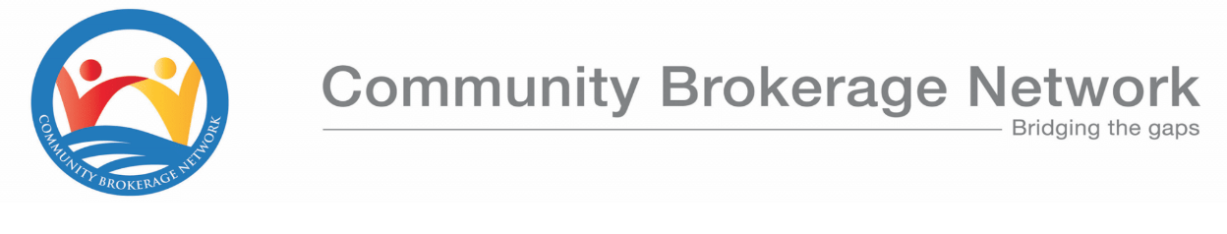

# Community Brokerage Award (GL 6804) – Candidate Application Form

## Personal Details

|  |  |
| --- | --- |
| Name |  |
| Address |  |
| Postcode |  |
| Date of Birth |  |
| Phone number |  |
| Email Address |  |
| SQA Candidate Number (if applicable) |  |
| What is the highest level of qualification you have? |  |

## Work Details

|  |  |
| --- | --- |
| Employer (if applicable) |  |
| Job Title |  |
| Will you be released from work to attend the learning days? |  |

## Support Needs

|  |
| --- |
| Tell us about any support you think you might need in accessing the course. This will help us to create a support plan for your learning and make sure assessments are accessible. |
|  |
| Do you have IT access to complete online learning and assignments? |
|  |

## Personal Statement

|  |
| --- |
| In no more than 500 words, tell us why you are applying for the course, any relevant experience you may have and what you hope to gain from participating. |
|  |

## Paying for the course

|  |  |
| --- | --- |
| How are you intending to pay for the course? (Employer funded or self-funding) |  |
| We may be able to contribute towards your costs including course fees and support costs such as a personal assistant, dyslexia support, childcare etc. If this would help you to access the course, please tell us more about how this could help. |  |

|  |  |
| --- | --- |
| If your employer is funding the course, please ask your manager to complete the following details. | |
| Manager’s name |  |
| Job Title |  |
| Phone number |  |
| Email address |  |
| Organisation’s address |  |
| Details for invoicing |  |
| Manager’s signature |  |

## Declaration

I declare that the information given is correct and any changes throughout the course will be declared to the Community Brokerage Network. I understand that my details will be held securely by the Community Brokerage Network and, if accepted onto the course, will be passed to SQA for certification purposes.

|  |  |
| --- | --- |
| Applicant signature |  |
| Date |  |

Completed form to be returned to [jennyreekie@communitybrokeragenetwork.co.uk](mailto:jennyreekie@communitybrokeragenetwork.co.uk)